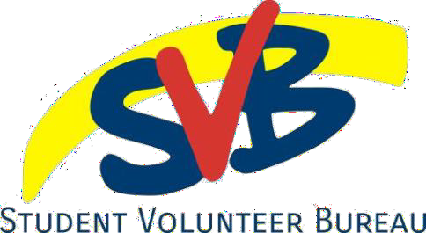
Personal/Professional Development Form
The VIP Program | GROW
Name: _ Student #: Fall/Winter/Spring: __ _ Year: _ VIP Level: _ Email: _ Name of session: __

What was the purpose of this session?

- What did you learn from this session?

_

Did this session help you make progress toward your future goals?

I, ___ , verify that all of the information on this form is accurate.
Your initials: _ Date: _

PART B – Session facilitator contact information
This form verifies that _ _ has completed a total of _ professional development hours through this organization on or before August 2nd, 2024 and has not received financial compensation or academic credit for their time.
Name: _ Date:
Signature: _
Contact email/telephone:

Access to Information and Protection Policy
All information requested by the VIP will be used solely for the administration and management of the program. Personal information is collected under the authority of the Access to Information and Protection of Privacy Act, 2015 (SNL2015 Chapter A-1.2) and is used for the purposes of administration and program planning. Questions about this collection and use of personal information may be directed to the Manager of the Student Experience Office at 709- 864-8819

